Jupiter Minecraft

Mixed reality experience

Theme and plot development

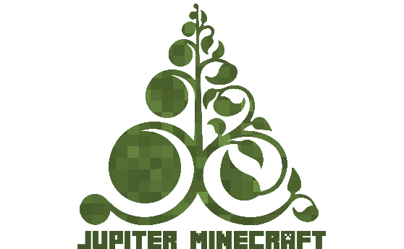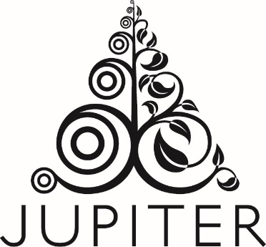

## Character Development Task

The character development task was presented during the Jupiter Minecraft workshop at Ratho Primary School. From traditional Scottish fairytale creatures presented in a booklet, children picked 8 characters and created one additional character. The children drew pixel art versions of the characters and wrote short descriptions, mostly related to specific places in Jupiter Artland.

Characters were intuitively assigned to artworks, according to the type of environment the creature would live in, eg. the mermaid, selkies, and kelpies were described as living in Life Mounds, because of the access to the water. Their descriptions and drawings will inspire the characters, plot and game itself. What is more, many children use their own names for the artwork within Jupiter Artland, for example Life Mounds were called Green Hills and The Light Pours Out Of Me The Crystal Cave. It may be worth considering using these names for the game. The creatures would have their own names as they exist in a different reality.

## Characters

### Cu Sith

A very old and wise large green fairy dog. He is gentle with children, but can be dangerous when getting protective over other characters. Cu Sith lives in and protects the forest area. The other creatures used to listen to him as the oldest and most powerful of the group. Now he is difficult to find and avoids company.

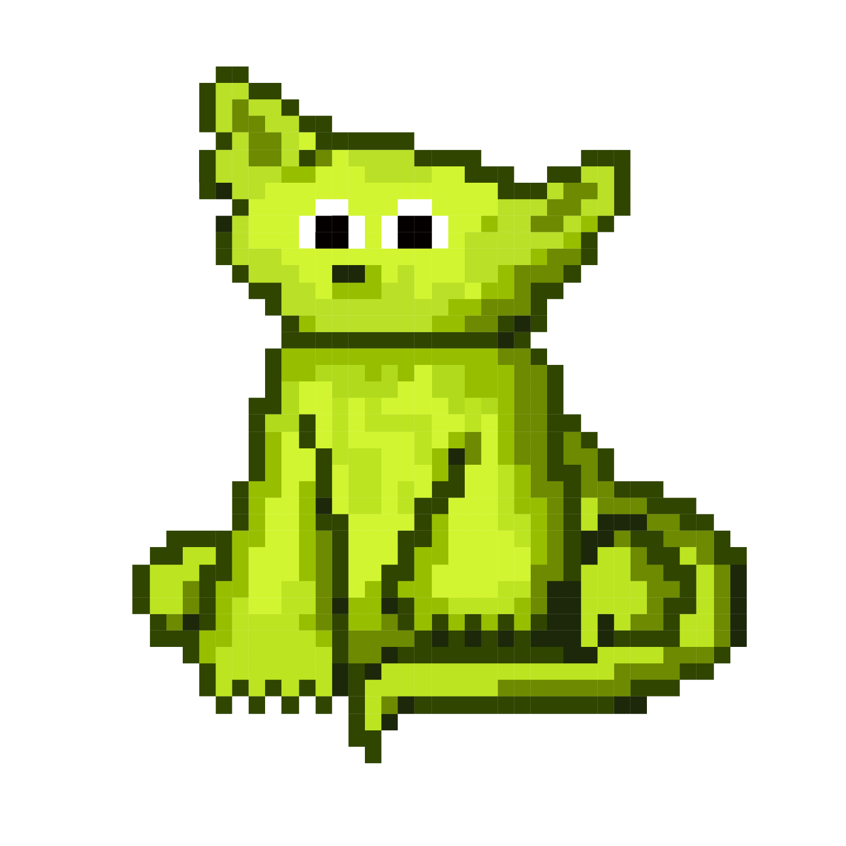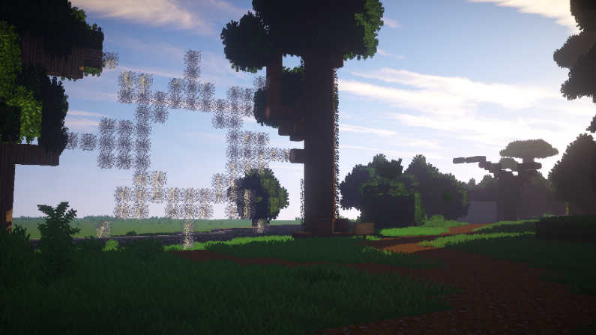

Kelpie

A green water horse who lives in the Duck Pond. He likes to run through the meadows sometimes, and visit the Crystal Cave (Light Pours Out of Me). Kelpie used to be very friendly letting people ride on his back but now he is not very trusting, sometimes even dangerous to people who come too close. He is a friend of the Selkies and sometimes they swim together. Kelpie is the only creature who is friend of Caillneach Bheur, sometimes they ride through the forest together.

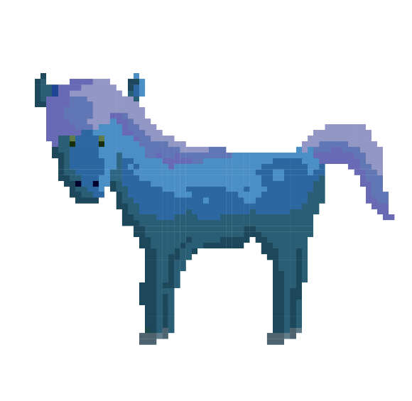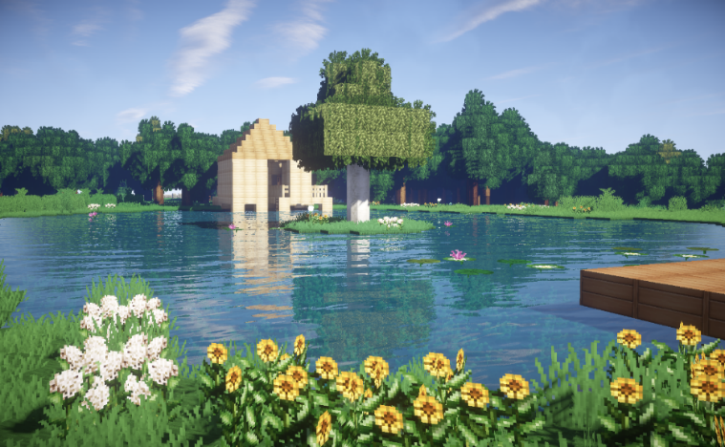

Caillneach Bheur - Blue Witch

A green water horse who lives in the Duck Pond. He likes to run through the meadows sometimes, and visit the Cristal Cave (Light Pours Out of Me). It used to be very friendly letting people to ride on their back but now they are not very trusty, sometimes even dangerous to people who come to close. It is a friend of Selkies and sometimes they swim together. The only creature who is friend of Caillneach Bheur. Sometimes they ride through the forest together.

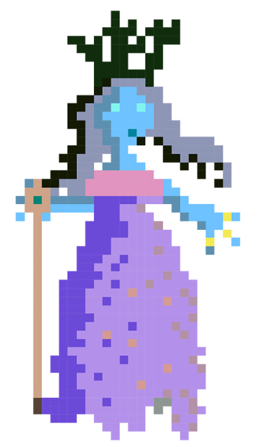 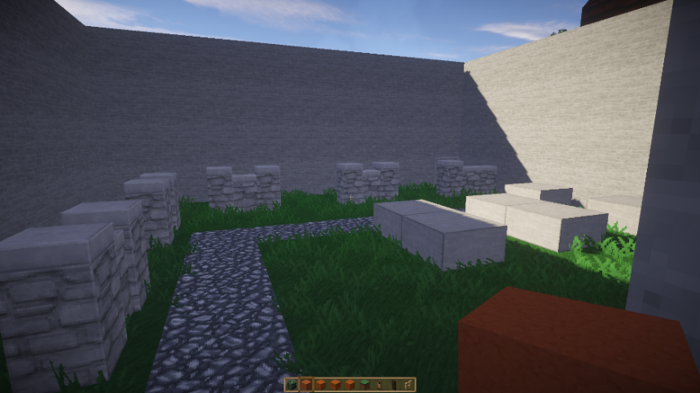

Selkies

These half –human, half – seals live in the left hand side pound next to Green Hills (Life Mounds). They are kind, gentle and very shy. They used to turn into the human form from time to time. Now they just stay in seal form, in order to be able to quickly swim away and hide in the water, which is deeper than it looks. When they run away, their eyes turn red. They like to swim with the Kelpie, and spend time with Ceasag which lives next to them.

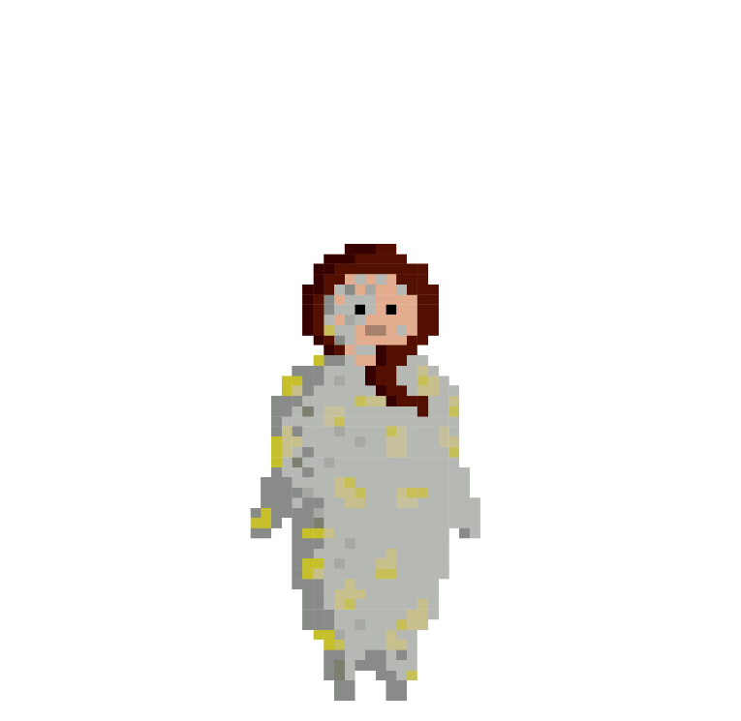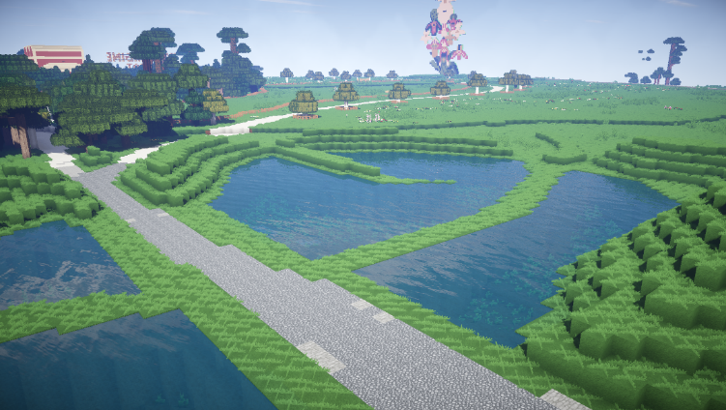

Cait Sith

This big black magic cat lives very long, and has known know Cu Sith for a long time. He lives at the Crystal Cave, as he protects its magical jewels. He use to give jewels to humans but now does not let anyone remove the magic stones. From time to time he visit Green Hills, to catch fish.

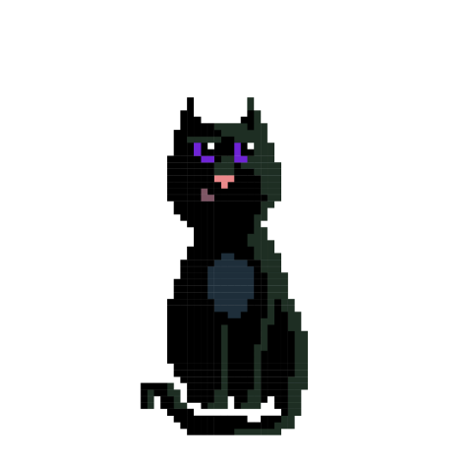 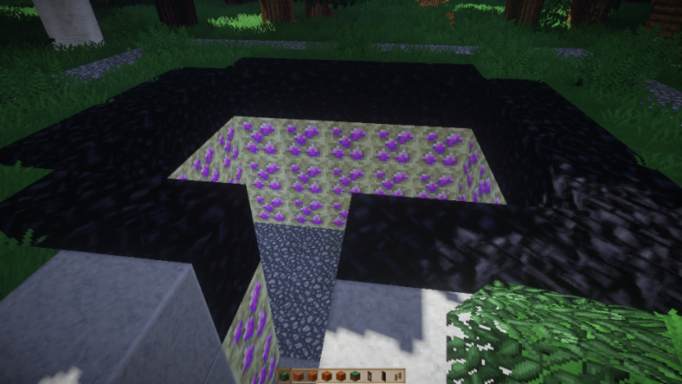

Ceasg

This mermaid lives in the second part of ponds, next to Green Hills. If she is captured by a human she can grant 3 wishes. She is quite dangerous as she has been known to drag people under water and drown them. She avoids people now, but used to be very kind and helpful.

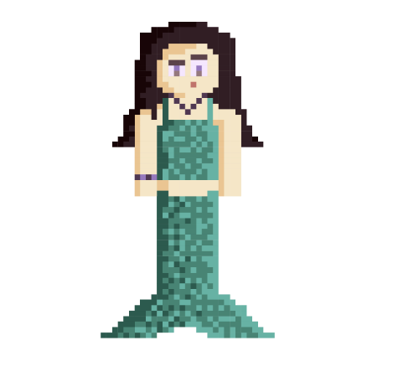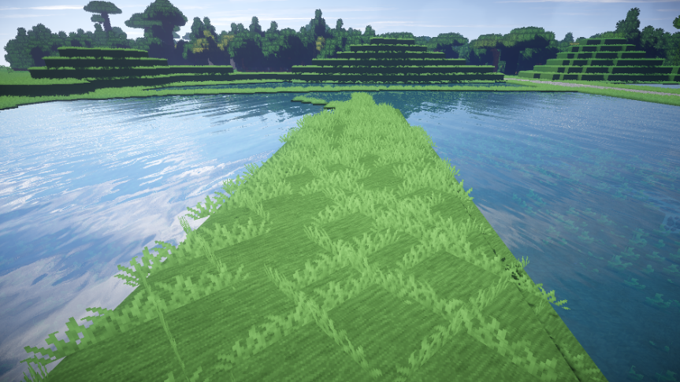

Brownie

This small brown troll used to help the villagers who lived in the surrounding farms. Brownie lives underground, mostly around Suck, as this is the entrance to his home. He gets on with everyone, although is very shy and sometimes can be very defensive. He is afraid of Cait Sith, as Cait attacked him and some chickens in the past. He still takes care of all the farm animals in Jupiter Artland.

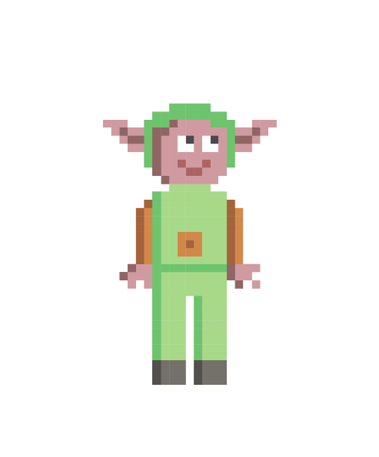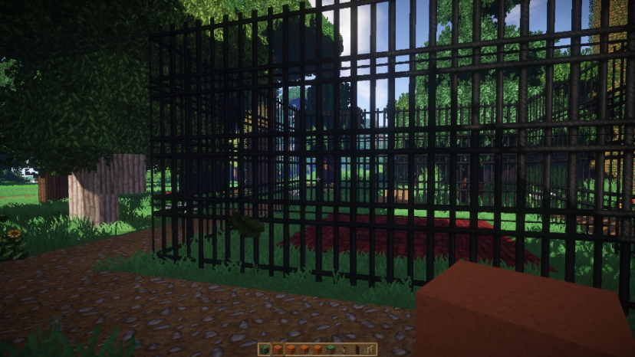

Glaistig

Half-goat, half-human, Glaistig lives in the Stone House, because she likes the rocky floor. She is friends with Ceasg because she is half-human too. Glaistig visits Green Hills quite often as she can jump, run and climb.

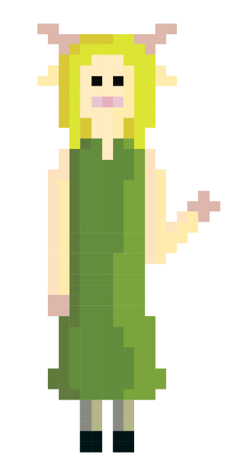 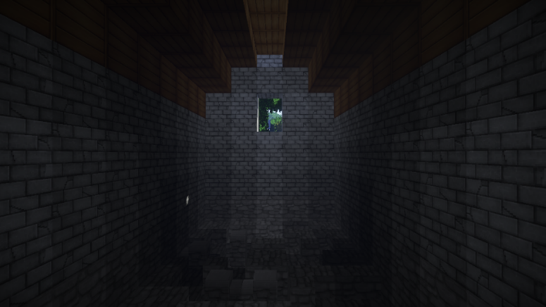

Brian

Brian used to be one of the villagers, jealous of the creatures’ magical powers. His lying and scheming has led to humans and the creatures mistrusting each other. Brian is the only mediator between the two groups meaning he has control over every situation.

He uses the magical powers of the creatures to control the village. Brian lives in Tree House, from where he observes the whole of Jupiter Artland.

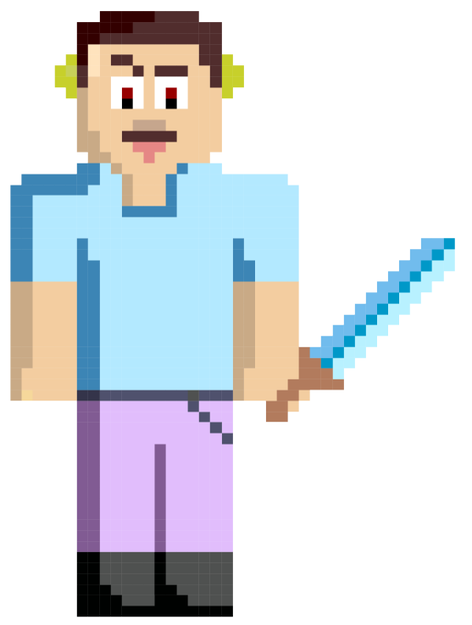 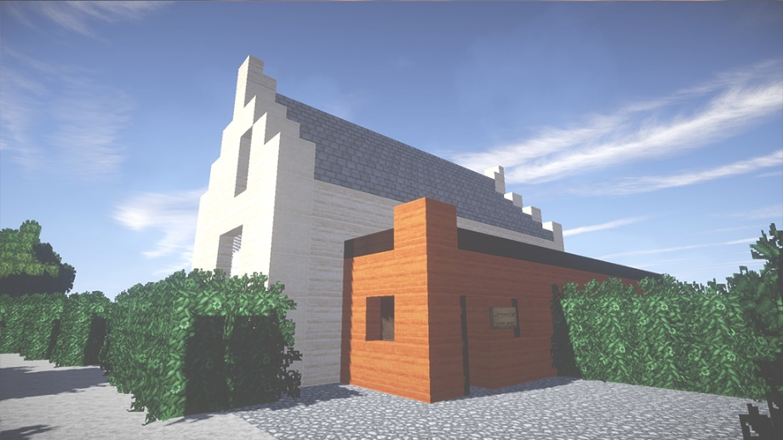

## Story synopsis

The plot of the game describes the relationship between the magical creatures and the humans in Jupiter Artland. A long time ago, all the magical creatures lived alongside humans and they helped each other. Humans were helped the creatures during difficult winters, and the magical creatures helped the humans with nature: protecting them, taking care of the livestock around the farms, helping them find their way when they were lost using theirs magical powers. Jupiter Artland was the favorite place of the creatures, because of its location. It is one of the few places where our human dimension is overlaid with a magical one, that of Minecraft. The creatures were able to travel between Minecraft and the human dimension at will. Everyone was happy and lived in peace. People were happy to have creatures as their neighbors and the magical creatures were not afraid to reveal themselves.

Unfortunately, not everyone was happy about the creatures. Brian, one of the villagers was jealous of their magic powers and he wanted to control the creatures. After a terrible flood, which covered most of the village he told the villagers it was the creatures fault. They could control nature so it must have been them. The villagers were scared so he offered to act as mediator between the creatures and the villagers. When he went to Jupiter Artland to talk to the creatures, he lied again. He said the villagers did it, they wanted to get rid of all of the creatures. They were angry, but scared. Brian’s plan worked. Both sides, villagers and creatures were scared, angry and trusted only him.

From this moment, the creatures started to hide, trusting only Brian. The creatures were trapped in the human dimension and some of the constructions from the Minecraft dimension stuck in the human world, which is why places like Crystal Cave, Green Hills, Duck Pond or Love Bomb are still visible for humans. Brownie, a goblin who was always close to people wants to find out the truth. Someone needs to help him to tell the creatures. It is not easy because they are scared, mistrustful and hiding, sometimes from each other. Brownie needs some help to find all of the creatures and find out who knows where there the chest with magic gold is hidden. Once the chest is open the creatures will be free to travel in and out of the Minecraft dimension again.

**Three Act structure**

**The three act structure is used to help develop rising tension and a more engaging narrative.**

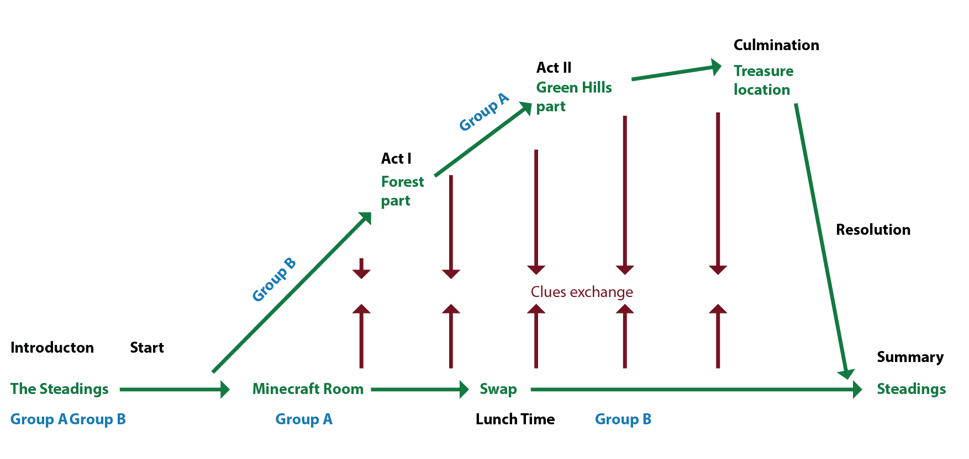

Structure of the game

1. Introduction
2. First part: Brownie, Glaistig, Witch, Cu Sith
3. Second part: Kelpie, Selkie, Mermaid, Caith Sith, Brian
4. The ending: Action twist and finding the treasure.